**CS5551 Advanced Software Engineering**

**LAB ASSIGNMENT #2**

**Weather Status**

**Description:** To check the status of the weather by given the city name.

Login:

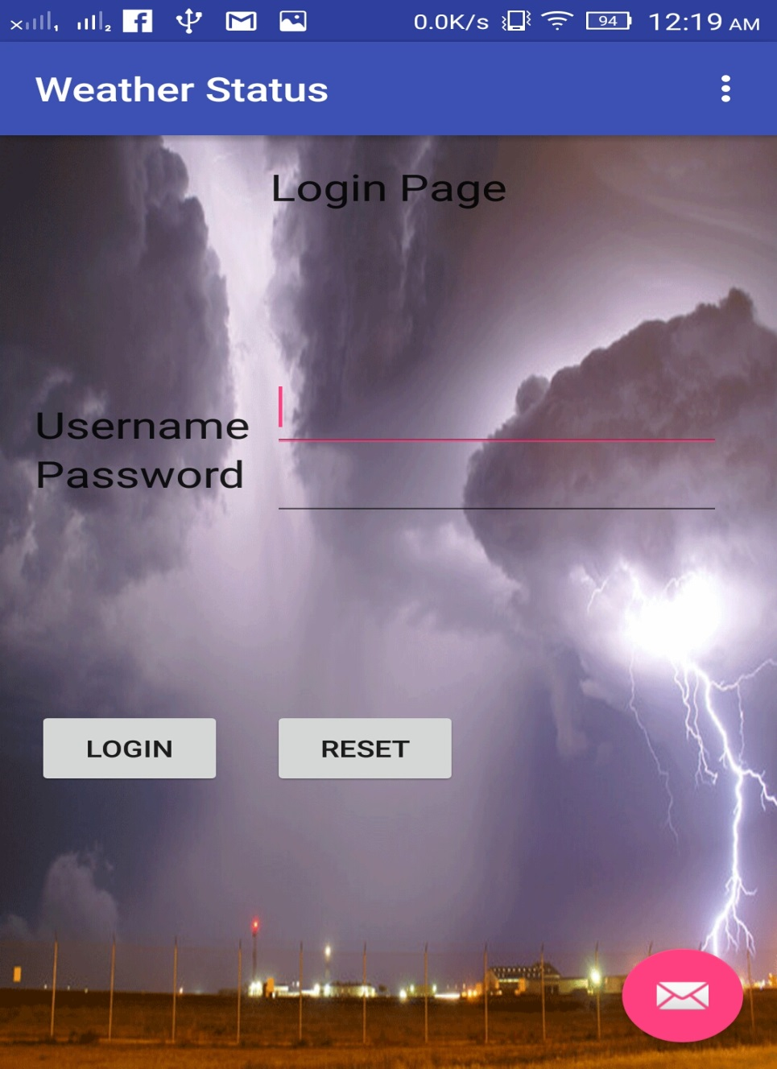

Weather Check status:

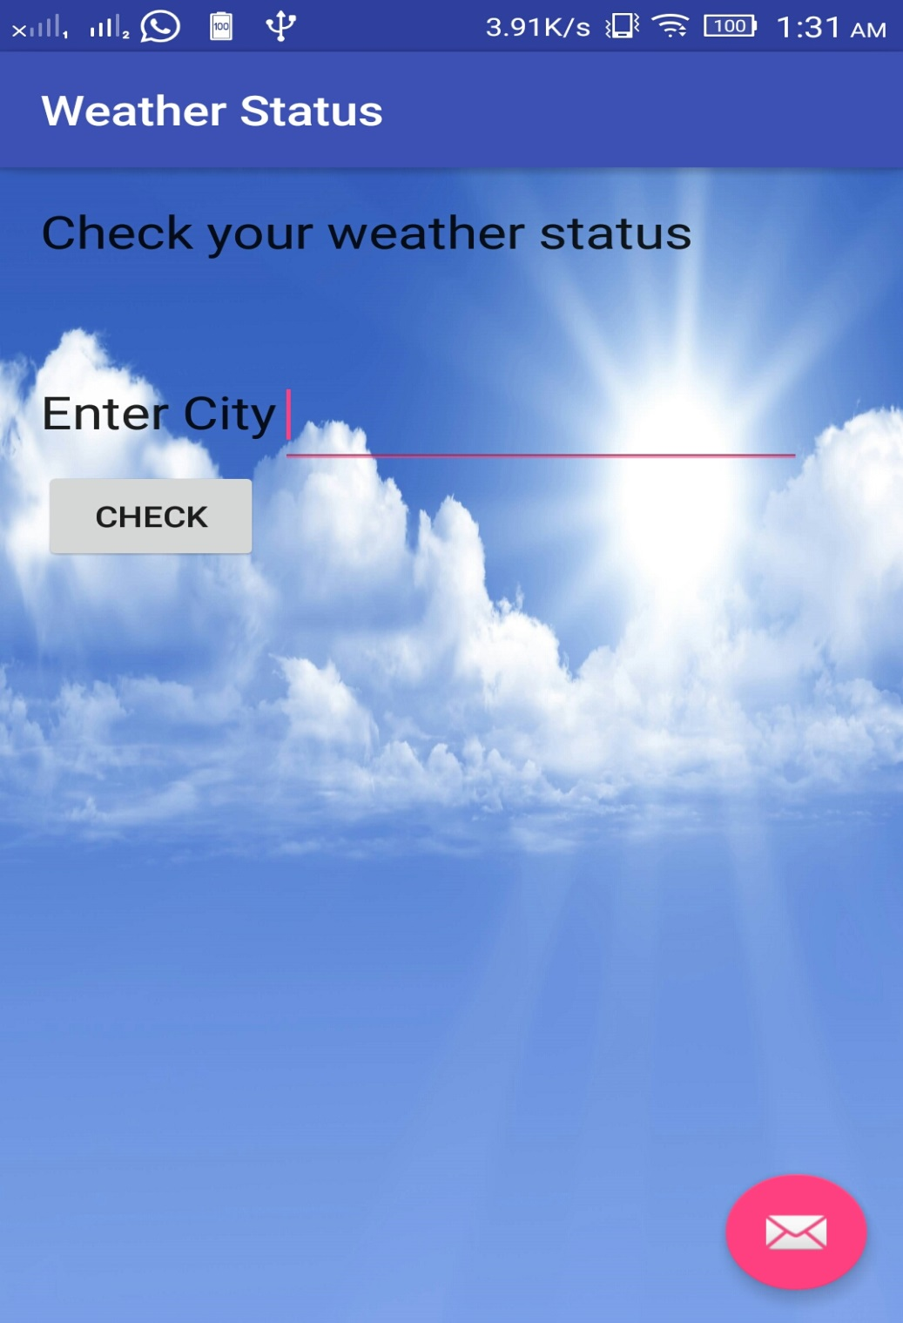

Weather Report:

